Document for Java Server Pages
Prepared By: Garun Mishra
Date: 2017-04-11

Java Server Pages:
=>Java Server pages seprate the dynamic part of your pages from the static HTML.
=>You simply write the regular HTML and then enclose the code for the dynamic parts in special tags most of which is start with “<%” and end with “%>”. For example: test.jsp
<html>
<body> <% out.println(“Hello this is first JSP”); %></body>
</html>
=>you normally give your file a.jsp extension, and typically install it in any place you could place a normal Web page.
=>Although what you write often looks more like a regular HTML file than a servlet, behind the scene, the JSP page just gets converted to a normal servlet, with the static HTML simply being printed to output stream associated with the servlet's service method.
=>JSP page is translated into a servlet and the servlet is compiled and loaded.
=> There are five main types of JSP constructs that you embeded in a page
- Scriptlet.
- Expression.
- Declearation
- Directive
- Action
=>Scripting elements(Scriptlet, expression, declearation) specify java code that will become a part of the resultant servlet, directive let you control the overall structure of servlet, and the Action let you specify existing components that should be used and otherwise control the behaviour of the JSP engine.
=>Diffrece between JSP, ASP, ASP.NET and Servlets
i) JSP and ASP:
->JSP and ASP is fairely similar in the functionality that they provide. JSP may have slightly higher learning curve.
-> Both allow embeded code in an HTML page, session variable and database access & manipulation. Where as ASP is mostly found on MicroSoft plateforms i.e. NT.
-> JSP can operate on any plateform that confirms to J2EE speciafication,
-> JSP allow component reuse by using JavaBeans and EJB's. Where as ASP provide the use of COM /ActiveX Control.
ii) JSP compared to ASP.NET:
ASP.NET is based on Microsoft .NET framework. The .NET frameworkallow applications to be developed using different programming languages such as Visual Basic, C# and JavaScripts. JSP and Java Still has the advantage that it is supported on many different plateforms and the Java community has many years of experience in designing and developing Enterprise quality scalable application. This is not to say that ASP.NET is bad, actually it is quite an improvement over the old ASP code.
iii) JSP compared to Servlet:
->A Servlet is a Java class that provides specila server side service. It is hard work to wrireHTML code in servlets.
->In servlet you need to have a lots of pritnln statements to generate HTML. JSP pages converted to Servlets so actually can do the same thing as old Java servlets.

=>Introduction to JSP comments:
Syntax | Purpose
<%-- comment --%> | It is a JSP comment. Ignored by JSP to Scriptlet translator. Any embedded JSP scripting elements, directives or actions are ignored.
<!-- comment --> | It is an HTML comment and passed through the resultant HTML. Any embedded JSP scripting elements , directives and actions are executed normally.
<% | This is used in templet text(static HTML) where you really want “<%”
%\> | It is used in scripting elelments where you really want “%>”
\' | It is a single quote in attribute that uses single quotes. Remember, however, that you can use single or double quotes and the other tyoe of quote will then be a regular character.
\'' | A double quote in an attributes that uses double quotes.Remember, however, that you can use either sinlge or double quote and the other type of quote will be then a regular character.
%\> | %> is an attribute.
<% | <% is an attribute.

List of JSP Syntax:
JSP Element | Syntax | Interpretation | Notes
JSP Expression | <%= expression %> | Expression is evaluated and placed in output. | XML equivalent is <jsp:expression> expression </jsp:expression>. Predefined variables are request, response, out, session, application, config, pageContext.(Available in scriptlet also)
JSP Scriptlet | <% code %> | Code is inserted into service method. | XML equivalent is <jsp:scriptlet> code </jsp:scriptlet>
JSP Declearation | <%! code %> | Code is inserted into body of servlet class, outside of service method. | XML is equivalent is <jsp:declearation> code </jsp:declearation>
JSP page directives | <%@ page att=”val” %> | Direction to the servlet engine about general setup. | XML equivalent is <jsp:directive.page att=”val” \>  import=”package-class” , contentType=”MIME-TYPE”  isThreadSafe=”true|false” , session=”true|false”  buffer=”sizekb|none” , autoflush=”true|false”  extends=”package.class” , info=”message”  errorPage=”url” , isErrorPage=”true|false”  language=”java”
JSP include directives | <% include file=”url” %> | A file on local system to be included when the JSP page is translated into servlet. | Xml equivalent is <jsp:directive.include file=”url” \>  the url must be relative one. Use the jsp:include action to include a file to request time instead of transalation time.
JSP comment | <% -- comment --%> | Comment ignored when the jsp page is transalated into servlet. | If you wanna to comment in an resultant HTML use regular HTML comment Syntax of <-- comment -->
The jsp:include action | <jsp:include page=”relative URL” flush=”true” /> | Include a file at the time the page is requested. | If you want to include the file at the time the page is translated, use page directive with the include attribute instead.  Warning: On the some of the server, include file must be an HTML file of JSP file, as determined by the server(Usually based on the file extension.)
The jsp:useBean action | <jsp:useBean att=val* /> or <jsp:useBean att = val* />  .....  </jsp:useBean> | Find or build a java beans | Possible attributes are:  id=”name” , scope=”page|request|session|application”  class=”package.class” , type=”package.class”  beanName=”package.class”
The jsp:setAttribute action | <jsp:setAttribute att=val* /> | Set Bean properties either explicitly or by designating that value comes from request parameter. | Legal Attributes are:  name=”beanName” , property=”Property Name”  param=”parameterName”  value =”val”
The jsp:getProperty | <jsp:getProperty name=”propertyName” value=”val” /> | Retrieve and output the bean property.
The jsp:forward action | <jsp:forward page=”relative URL” /> | Forward request to another page.
The jsp:plugin action | <jsp:plugin attribute=”val” * >  .....  ....  </jsp:plugin> | It will generate OBJECT or EMBEDDED tags, as approprate to the browser type, asking that an applet be run using the java Plugins.

JSP Scripting Elements: Scriptlet, Expression, Declearation
=>There are three Scriping elements which is given as follows:
i) Expressions of the form <%= expression %> that are evaluate and inserted into the output.
->JSP expression is used to insert java values directly into the outpt. It has the following form:
<%= Java expression %> : The java expression is evaluated, converted to a string, and inserted in the page.
Current Time: <%= new java.util.Date(); %>
-> Predefined variable that you can use is, HttpServletRequest request; HttpServletResponse response ; HttpSession session and out, the PrintWriter(a buffered version of type JspWriter) used to send the uotput to the client. Example:
Your Host Name: <%= request,getRemoteHost(); %>

ii)Sciptlet of the form <% code %> that are inserted into the server's service methods
If you want to do something more complex than insert a simple expression, JSP scriptlets insert code into the service() method of the generated servlet. This scriptlet have the following form:
<% code %> : scriptlet have access the same automatically defined variables as expressions. Example:
<% String name = request.getParameter(“name”);
out.println(“name : ”+name);
%>

iii) Declearation of the form <%! code %> that are inserted into the body of the servlet class, outside of any existing methods.
A JSP declearation define methods or fields that are get inserted into the main body of the servlet class(outside of the service method processing request). It has the following forms:
<%!
public int getValue(){
return 78;
}
%>
The method we can use in Expression also <%= getValue() ; %>

=>Predefined Objects/Implicit Object in JSP:
-> There are nine implicit objects variables . The variables are request., response, out, session, application, config, exception, pageContext, and page.
1) request: This object is the HttpServletRequest associated with the request, and the request parameters(via getParameter), the request type(GET, POST, HEAD, etc.) , and the incoming HTTP headers(cookies, Referer, etc.).
2) response: This is the HttpServletResponse associated with the response to the client.
3) out : This is the PrintWriter used to send output to the client. This is a buffered version of PrintWriter called JspWriter. Note that you can adjust the buffer size, or even turn buffering off, through use of the buffer attribute of the page directive.
4)session: This is the HttpSession object associated with the request. Recall that sessions are created automatically, so this variable is bounded even if there was no incoming session reference. The one exception is if you use the session attribute of the page directive to turn sessions off, in which case attempts to reference the session variable cause error s at the time the JSP page is translated into a servlet.
5)application: This is the servletContext as obtained via getServletConfig().getContext().
6)config: This is the ServletConfig object for this page.
7)pageContext: JSP introduce a new class called PageCOntext to encapsulate the use of server-specific features like higher performance JspWritter. The idea is that, if you access them through this class rather than directly, your code will still run on “regular” servlet/JSP engine.
8) page: this is simply a synonyms for this, and is not very useful in Java. It was created as placeholder for the time when the scripting language could be something other than Java.
9)exception: In JSP, exception is an implicit object of type java,lang.Throwable class. This object can be used to print the exception. But it can only be used in error pages. .
The Exception object allow the exception datat to be accessed by designated JSP. Example:
<%page isErrorPage=”true” %>
<html>
<body> Sorry following exception occured: <%= exception %> </body>
</html>

=>JSP Actions:
->JSP action use to constructs SML in Syntax to control the behaviour of the servlet engine. You can dynamically insert a file, reuse JavaBeans components, forward the user to another page, or generate HTML for the Java Plugins. Available actions include:
i) jsp:include – Include a file ate the time the page is requested.
ii)jsp:useBean – Find the instance of Java Beans.
iii) jsp:setProperty – Set the property of Java Beans
iv) jsp:getProperty – Insert the property of a java bean into the output.
v) jsp:forward – forward a new request to another page.
vi) jsp:plugin – Generate browser-specific code to makes an OBJECT or EMBEDDED tags for the Java Plugin.

=>JSP Cookies:
-> Cookies are short piece of data sent by web server to the client browser.
-> Cookies are saved to clients hard disl in the form of small text file.
-> Cookies helps the web servers to identify the web users, by this way server track the user. Cookies play an import role in the session tracking.
-> In JSP cookies are the object of the class javax.servlet.http.Cookie.
->This class is use to creates a cooikes, a small amount of information sent by a servlet to a Web browser, saved by the browser, and later sent to track the server.
-> A cookies value can uniquely identify a client, so cookies are commonly used for session management.
->Cookies objects have the following methods:
a. getComment(): Return comment describing the purpose of this code, or null if no such comment has been defined.
b. getMaxAge(): Returns maximum specified age of the cookies.
c. getName(): Return the name of cookies.
d. getPath(): Returns the prefix of all URLs for which this cookies is targeted.
e. getValue(): Returns the value of the cookies.
f. getComment(String): If a web browser present in this cookie to a user, the cookie's purpose will be described using this comment.
g. setMaxAge(int seconds):Set the maximum age of the cookie. The cookie will expire after that mentioned seconds have passed. Negative value indicate that cookie is not stored persistently and will be deleted when the user web browser exits. The zero value cause that the cookie to be deleted.
h. setPath(String): This cookies should be presented only with requests begining with this URL. For example:
cookie.setPath(http://localhost:8080/test/tutorials);
then the cookie will be available for all within “/test/tutorials/” not for “/test/jdbc/”.
i. setValue(String): Sets the value of cookies. Value with various special characters(white space, brackets and parantheses, the equal signs, comma, double quote, slashes, question marks, the @ sign, colon, and semicolon) should be avoided. Empty values may not behave the same way on all browsers.

Architecture of JSP:
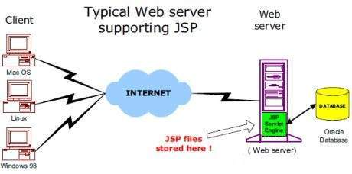

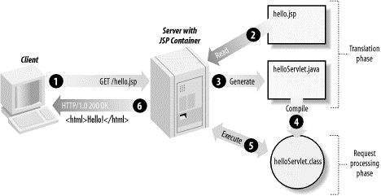
Flow of JSP:

Life Cycle of JSP pages:
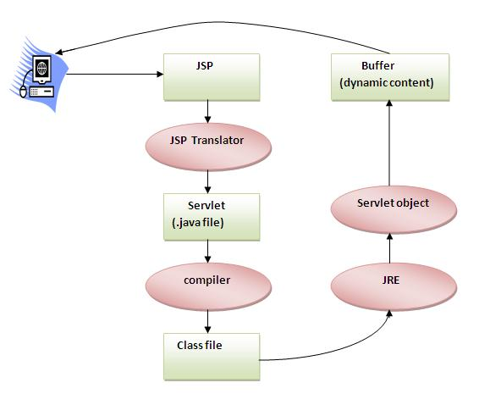
=> The JSP pages follows these steps:
- Translation of the JSP page.
- Compilation of JSP page.
- ClassLoading(class file is loaded by class loader)
- Instantiation(Object of Generated Servlet is created)
- Initialization(JspInit() method is invoked by the container)
- Request processing(_jspService() method is invoked by the container)
- Destroy(jspDestroy() method is invoked by the container)

